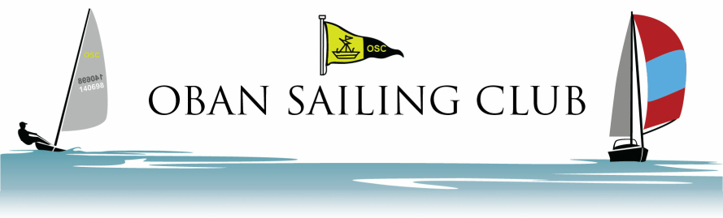
Oban Town Keelboat Regatta

ENTRY FORM
Boat Name
Sail Number
Design
Owner/Skipper
Number of crew
Club (RRS 75.1(a))
CYCA Handicap
Class Entered
The boat is covered by insurance for Racing and Third Party risks of at least £2,000,000.

I certify that the above details are correct. I agree to be bound by the
Racing Rules of Sailing and all other rules that govern this event.

Signed …………………………………………………………
Date …………………………………………………………

Name ……………………………………………………
Address ……………………………………………………
……………………………………………………
……………………………………………………

Telephone (home) ………………………………………
Telephone (mobile) ………………………………………
e-mail ………………………………………

Entry fee Keelboats £10.00 both days, £5 per day

BACS transfer is preferable:
Account 0078 4705
Sort Code 80-17-99 (Bank of Scotland)
Payment Reference: your surname.

Cheques should be made payable to OBAN SAILING CLUB

Entries should be submitted at the briefing or completed online https://forms.gle/JHs4BVCBGwAzvus4A

