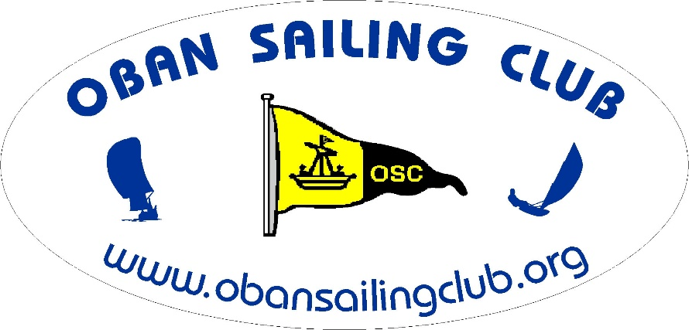
A Fun Keelboat Race
Join us for a slightly different type of Race
(Perhaps not quite as competitive as usual!)

This race has a course which can be affected by tide times and direction as well as wind and weather, so to introduce an element of navigation skills, competitors are required to nominate their own start time in advance within a window of allowable times!

Date:- Sunday September 6th

Start Time:- Any time between 1330 and 1500 hrs
Pick your start time and text your intended time to 07721 868769 at least
1 hour before starting. This text is for information only - do not expect a reply!

Course:- OSC normal Club Start line between Clubhouse and Sgeir Rathaid South buoy S
S – R - Creags Islands (whole group) – R – S
R & S to be left to port after start and to starboard before finishing.
The Creags Island group may be left to either hand.
The finish line will be the normal Club finish line between the Club house and Sgeir Rathaid South buoy, S
Take your own time at the finish and text to 07721 868769.

Corrected times will be calculated using the CYCA handicap system.

