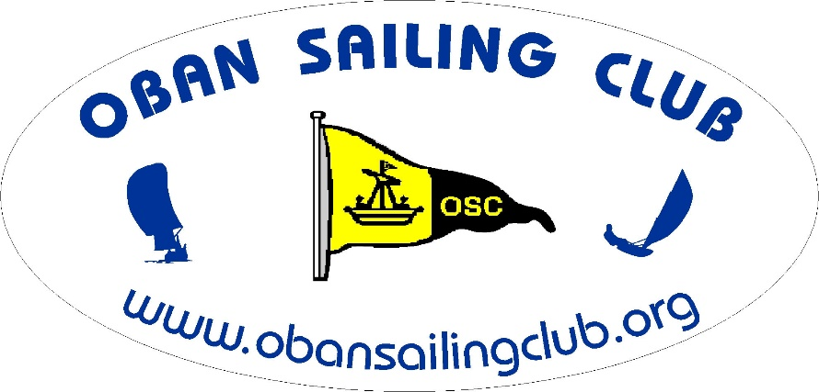
A Fun Keelboat Race
Join us for a slightly different type of Race
(Perhaps not quite as competitive as usual!)

This race has a course which can be affected by tide times and direction as well as wind and weather, so to introduce an element of navigation skills, competitors are required to nominate their own start time in advance within a window of allowable times!

Date:- Sunday August 23rd
Start Time:- Any time between 1300 and 1430 hrs
Pick your start time and text your intended time to 07376 124399 at least
1 hour before starting. This text is for information only - do not expect a reply!

Course:- OSC normal Club Start line between Clubhouse and Sgeir Rathaid South buoy S
S – Island of Kerrera - S
The Island of Kerrera may be left to either port or starboard.
The finish line will be the normal Club finish line between the Club house and Sgeir Rathaid South buoy, S
Take your own time at the finish and text to 07376 124399.

Corrected times will be calculated using the CYCA handicap system.

