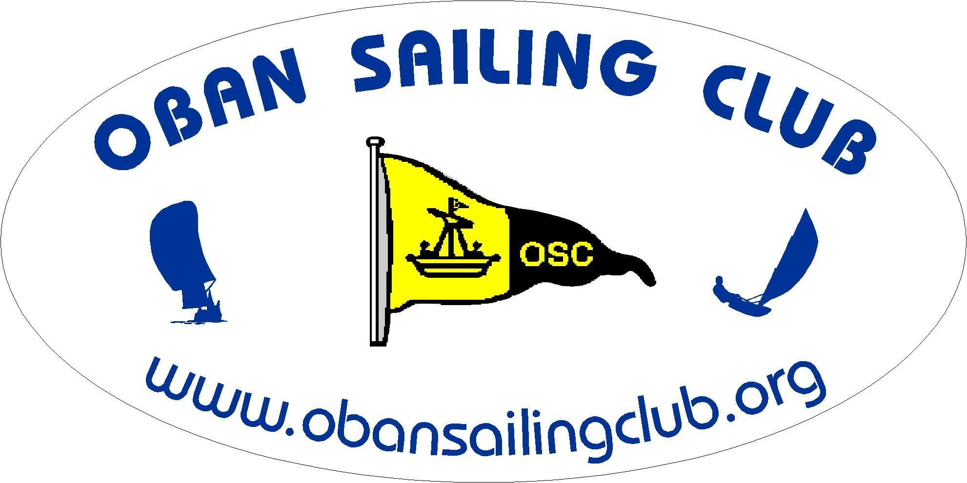OBAN SAILING CLUB

DATA PROTECTION POLICY APRIL 2018

1. **About this Policy**

1.1. This policy explains when and why Oban Sailing Club collects personal information (including opinions) about its members and instructors, how it is used, how it is kept secure together with related members rights.

1.2. The Club may collect, use and store personal data as described in this Data Protection Policy and as noted at the time the data is collected from members.

* 1. The Club reserves the right to amend this Data Protection Policy from time to time

without prior notice. Members are advised to check the Club website *www.obansailingclub.org* or the Club notice board regularly for any amendments.

* 1. Personal data will not be shared with any third parties without prior consent (which

can be withheld) except where required to do so by law.

1.5. The Club will always comply with the General Data Protection Regulations (**GDPR**) when dealing with personal data. Further details on the GDPR can be found at the website for the Information Commissioner (www.ico.gov.uk). For the purposes of the GDPR, The Club Secretary will be the “controller” of all personal data we hold about club members and instructors.

|  |  |
| --- | --- |
| 1. **What information is collected and why.**   **Type of information** | **Purpose** |
| Member's name, address, telephone numbers, e-mail address | Managing the Member’s membership of the Club. Managing the duty roster. The Club will seek consent in the renewal/application form before sharing this information with club members in the club handbook. |
| The names and ages of the Member’s dependants. | Managing the Member’s and their dependants’ membership of the Club. |
| Emergency contact details. Medication | Contacting next of kin in the event of emergency.  Provide possible special supervisory measures/restrictions during training. |
| Date of birth / age related information. | Managing membership categories which are age related. |
| Gender. | Provision of adequate facilities for members.  For the purposes of reporting gender data to the RYA and sports councils. |
| The Member’s name, boat name and sail number | Managing race entries and race results. Supplying race results to local and national media. |
| Photos and videos of members and their boats | Putting on the Club’s website and social media pages and using in press releases. Members will be asked to give consent on the membership renewal/application form. Members may withdraw their consent at any time by contacting the Club by e-mail or letter. |
| Instructor’s name, address, email addresses, phone numbers and relevant qualifications and/or experience. | Managing instructors and parents or guardians at the club. So that those offering instruction can be contacted and to provide details of instructors to members. |

**3 How personal data is protected**

3.1 The Club will process membership and training information electronically and hold all information on a database on a secure computer based in the EU. A backup of this information will be held on a “cloud”. Membership and training forms will be held in a secure cabinet.

3.2 The RYA Training Centre Principal, Training Coordinator and appropriate Chief Instructor will also process and hold information pertaining to trainees and make this information available to instructors only as required.

**3.3** Please note however that transmission of information over the internet can never be guaranteed to be 100% secure.

**3.4** For any on-line payments which are taken from members or trainees, a recognised online secure payment system will be used. Bank details will not be recorded.

**3.5** Members will be promptly notified in the event of any breach of their personal data.

* 1. Member’s personal data will never be sold or passed on.

**4 How long is membership and training information kept?**

4.1. Members/ trainees’ personal data will be held on the systems for as long as they are a member of the Club and for 3 years after they have left the club, unless required to do so for any legal reasons. Personal data will be reviewed every year to establish whether the Club is still entitled to process it or not.

**5. Members rights**

**5.1.** Members have rights under the GDPR:-

5.1.1. to access their personal data

5.1.2. to be provided with information about how their personal data is processed

5.1.3. to have their personal data corrected

5.1.4. to have their personal data erased in certain circumstances

5.1.5. to object to or restrict how their personal data is processed

5.2. Members have the right to take any complaints about how their personal data is processed to the Information Commissioner: https://ico.org.uk/concerns/ 0303 123 1113.

For more details, any questions, comments and requests regarding the Club data processing practices should be addressed to the Club Secretary. [secretary@obansailingclub.org](mailto:secretary@obansailingclub.org)